SIMATS ENGINEERING
CO5 - ASSESSMENT TOOL 1
Design Desk
COURSE NAME: Deep Learning COURSE CODE: MLA0408

COURSE OUTCOME COVERED

CO5: Students will be able to analyze and explain advanced generative deep learning models including Autoencoders, Deep Belief Networks, Boltzmann Machines, Deep Boltzmann Machines, and Generative Adversarial Networks. They will be able to compare their architectures, explain their learning mechanisms, and apply suitable generative models to real-world problems. (BTL-3)
Assessment Tool Weightage: 30%

QUESTIONS:

1. Design an Autoencoder-Based Feature Learning System
A manufacturing company wants to detect defective products from high-dimensional sensor data. Design an Undercomplete Autoencoder with suitable encoder, latent representation, decoder, activation functions, and reconstruction loss. Explain how the design performs dimensionality reduction and feature learning.
2. Design a Robust Regularized Autoencoder
A healthcare organization has noisy patient-record features and needs a robust representation for downstream classification. Design a Regularized Autoencoder using an appropriate regularization strategy. Explain the encoder-decoder structure, regularization mechanism, training objective, and how the design reduces overfitting and improves useful feature extraction.
3. Design a Deep Generative Model
A recommendation or content-generation system requires learning complex data distributions. Design a Deep Belief Network or Deep Boltzmann Machine using suitable visible and hidden layers. Illustrate the architecture, explain the learning process, and justify the choice of the model for the proposed application.
4. Design a Stochastic and Contractive Representation Model
A real-world image or signal-processing application requires representations that remain useful under small input variations. Design a model using Stochastic Encoders/Decoders or a Contractive Encoder. Specify the architecture, objective function, and robustness mechanism, and explain how the design improves representation stability.
5. Design a GAN-Based Data Generation System
An organization has limited training images and wants to generate realistic synthetic samples. Design a Generative Adversarial Network with a Generator and Discriminator. Specify the input, network flow, adversarial training process, loss functions, and evaluation approach. Compare the proposed GAN design with an Autoencoder and justify why GAN is suitable for the application.
Design Desk Guidelines
- Identify the real-world problem, requirements, inputs, outputs and constraints.
- Draw a clear architecture or workflow diagram for the proposed model.
- Specify important layers, units, activation functions, latent representation and loss functions.
- Explain the training or learning mechanism and justify major design choices.
- Mention suitable evaluation measures and expected outcomes.
- Use neat labeling and present the design in a logical sequence.
- The solution should be original and written in the student's own words.
Code of Conduct:
I vemula saiteja 192425083 (Name / Reg No) certify that this submission is my original work and that I have adhered to the guidelines specified for this assessment. I understand that any violation of academic integrity rules will result in disciplinary action.
Signature of the student:
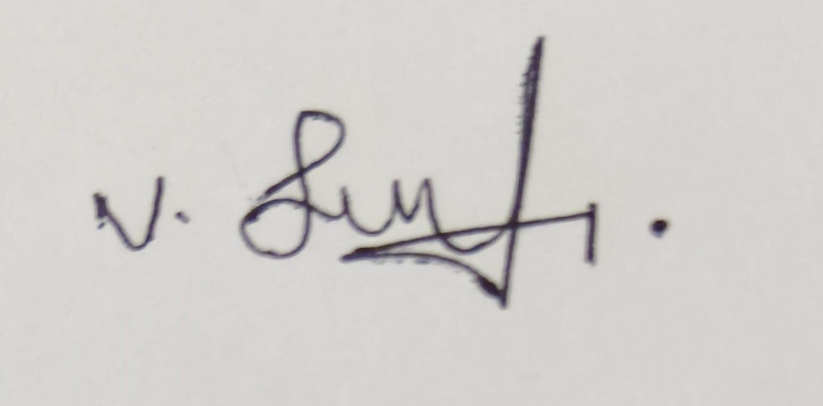
RUBRICS FOR CALCULATION:
Criteria | Weightage | Level 4 Exemplary | Level 3 Proficient | Level 2 Developing | Level 1 Beginning
Understanding of Problem Context | 20 | Clearly understands the problem, requirements, constraints, and expected outcomes. | Good understanding with minor gaps in requirements. | Basic understanding; some requirements are unclear. | Poor understanding or misinterpretation of the problem.
Application of Concepts | 30 | Accurately applies appropriate generative deep learning concepts and architectures. | Applies relevant concepts correctly with minor errors. | Applies basic concepts with limited accuracy. | Fails to apply appropriate concepts.
Design Approach | 20 | Innovative, logical, well-structured, feasible, and technically justified design. | Logical and feasible design with minor gaps. | Basic design with some inconsistencies. | Unclear, illogical, or impractical design.
Accuracy of Solution | 20 | Completely correct architecture, process, objectives, and justification. | Mostly correct with minor technical errors. | Partially correct solution with noticeable gaps. | Incorrect or incomplete solution.
Clarity | 10 | Clear, well-organized diagram and explanation with proper technical labeling. | Understandable with minor clarity issues. | Limited clarity and explanation. | Poorly presented and difficult to understand.

1. Design an Autoencoder-Based Feature Learning System

Real-World Problem
A manufacturing company collects high-dimensional sensor data such as temperature, pressure, vibration, speed, humidity, current, and machine noise. Many sensor features may be redundant or correlated. The objective is to learn a compact representation of the sensor data and use it to identify defective products.

Requirements
- Input: High-dimensional sensor vector, for example 100 sensor features.
- Output: Reconstructed sensor vector and a compact feature representation.
- Constraint: The model should reduce dimensionality without losing important information.
- Goal: Learn useful features automatically for defect detection.

Proposed Undercomplete Autoencoder
An undercomplete autoencoder uses a latent layer having fewer neurons than the input layer.

Architecture;
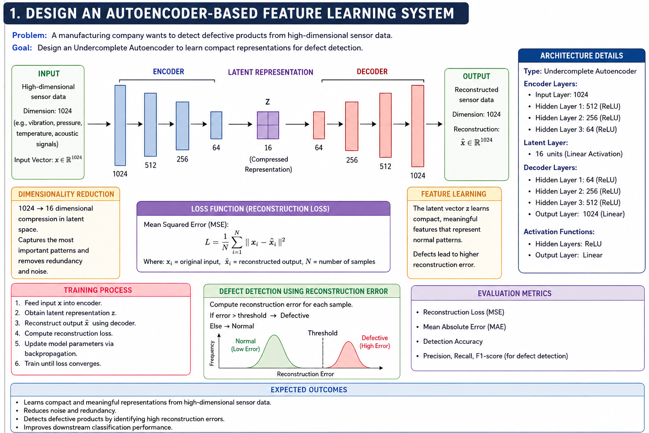
The encoder converts the original 100-dimensional sensor vector into a 10-dimensional latent representation. The decoder then attempts to reconstruct the original 100-dimensional input from this compact representation.

Activation Functions
ReLU is suitable for the hidden layers because it learns nonlinear relationships between sensor measurements efficiently. A linear activation can be used in the output layer when the sensor values are continuous and appropriately normalized.

Reconstruction Loss
The most suitable loss is Mean Squared Error (MSE):
[
L=\frac{1}{n}\sum_{i=1}^{n}(x_i-\hat{x}_i)^2
]
where (x_i) is the original sensor value and (\hat{x}_i) is the reconstructed value.

Dimensionality Reduction and Feature Learning
Because the latent layer contains only 10 neurons compared with the original 100 features, the network is forced to retain only the most important information. The encoder therefore learns combinations of sensor features representing machine conditions. Instead of manually selecting features, the autoencoder automatically discovers useful patterns.
For defect detection, the learned 10-dimensional latent features can be provided to a classifier such as SVM, Random Forest, or a neural network. A defective product may also produce a larger reconstruction error because its sensor pattern differs from normal training patterns.

Training Process
The autoencoder is trained by minimizing reconstruction error. During each iteration, sensor data passes through the encoder and decoder, the reconstruction is compared with the original input, and backpropagation updates the weights.

Evaluation Measures
- Reconstruction MSE
- MAE
- Classification accuracy
- Precision
- Recall
- F1-score
- ROC-AUC

Expected Outcome
The system should reduce a high-dimensional sensor vector to a compact representation while preserving important manufacturing information. This reduces computational complexity and provides useful automatically learned features for detecting defective products.

2. Design a Robust Regularized Autoencoder

Real-World Problem
Healthcare organizations often store patient information containing laboratory measurements, demographic variables, vital signs, medical-history features, and other attributes. Such data can contain noise, missing information, and irrelevant variations. A normal autoencoder may learn these unwanted patterns and overfit.
A Denoising Autoencoder with regularization can provide a more robust solution.

Requirements
- Input: Noisy patient-record features.
- Output: Clean reconstructed representation.
- Goal: Learn useful features for downstream disease classification.
- Constraint: Avoid overfitting and prevent the model from simply memorizing the input.

Proposed Architecture
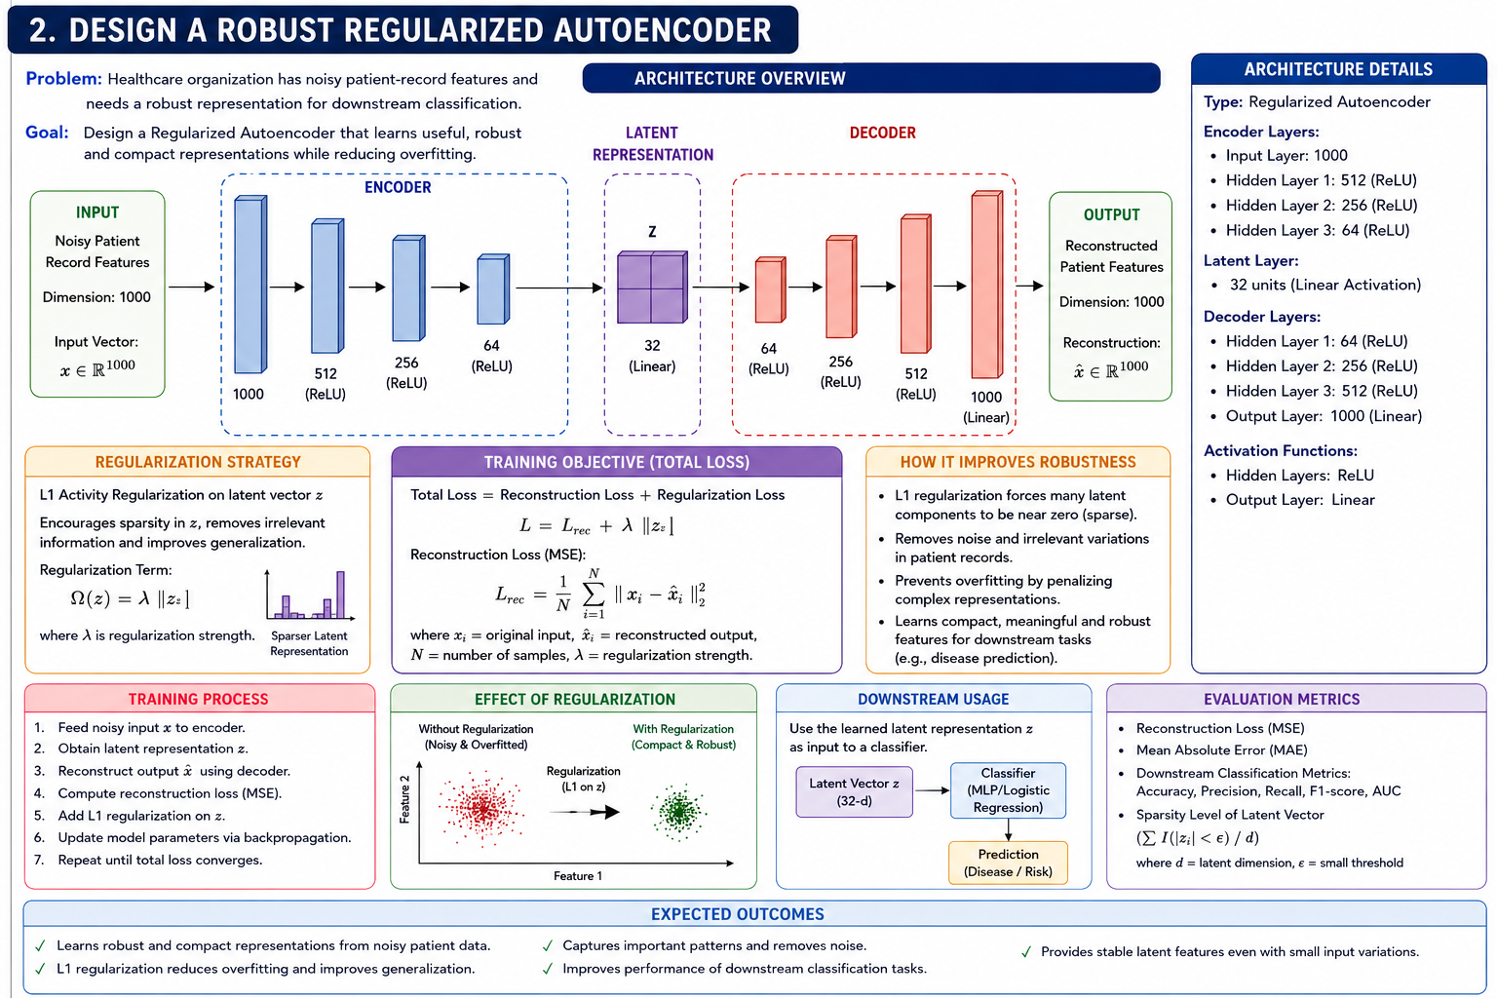

Regularization Strategy
A suitable approach is L2 weight regularization combined with input noise and dropout.
L2 regularization adds a penalty for large weights:
[
L_{total}=L_{reconstruction}+\lambda\sum W^2
]
where (\lambda) controls the strength of regularization.
Dropout can also randomly deactivate some neurons during training. This prevents the network from depending heavily on particular neurons.

Training Objective
The model receives a corrupted version of the patient data but tries to reconstruct the original clean data.

[

L_{total}
MSE(x,\hat{x})
+
\lambda ||W||_2^2
]
Thus, the network must learn stable and meaningful patterns instead of memorizing noise.

How Robustness Is Achieved
During training, small amounts of noise can be added to the input. For example, some features can be randomly masked or Gaussian noise can be introduced. The encoder learns to identify the important underlying structure even when some input information is unreliable.
The latent representation can then be given to a classifier for disease prediction or patient-risk classification.

Evaluation
The system can be evaluated using:
- Reconstruction MSE
- MAE
- Classification accuracy
- Precision
- Recall
- F1-score
- AUC
- Performance under noisy input

Expected Outcome
The regularized autoencoder should produce a compact and stable patient representation. L2 regularization, dropout, and denoising prevent overfitting and help the model focus on clinically useful patterns rather than noise.

3. Design a Deep Generative Model

Real-World Problem
A recommendation or content-generation system needs to learn complex relationships between users and items. For example, a movie recommendation system must learn hidden preferences such as preferred genre, language, actor, duration, and viewing patterns.
A Deep Belief Network (DBN) can be designed to learn hierarchical representations of user-item data.

Requirements
- Input: User-item interaction vector.
- Output: Learned user preference representation and recommendations.
- Goal: Learn hidden patterns from high-dimensional interaction data.
- Constraint: The model should capture complex dependencies.

Proposed DBN Architecture
A DBN is constructed by stacking multiple Restricted Boltzmann Machines (RBMs).
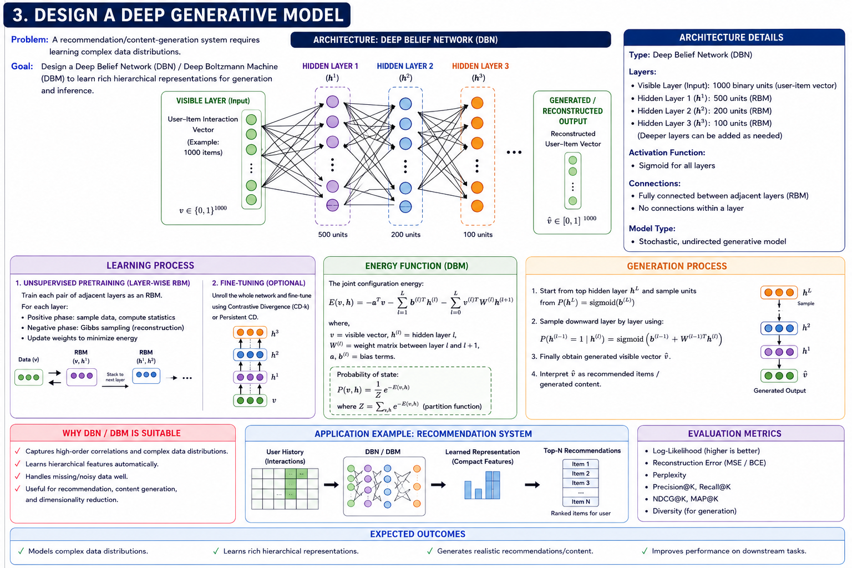

Layers
The visible layer represents observed user-item interactions. The first hidden layer learns simple patterns such as genre preferences. Higher hidden layers learn more abstract relationships, such as combinations of genres, actors, or viewing behaviors.

Learning Process
The DBN is generally trained in two stages.

1. Unsupervised Pretraining
Each RBM is trained separately. The first RBM learns from the original input. Its hidden representation is then used as input for the next RBM. This process continues through the network.

2. Fine-Tuning
After layer-wise pretraining, the complete network can be fine-tuned using backpropagation for the recommendation objective.

Why DBN?
A DBN is useful when the underlying data contains complex hidden relationships. It can automatically learn hierarchical representations instead of depending completely on manually engineered features.
For example, lower layers may learn basic viewing patterns, while deeper layers can represent more complex user preferences.

Evaluation
A recommendation system can be evaluated using:
- Precision@K
- Recall@K
- F1-score
- NDCG
- Mean Average Precision
- Recommendation accuracy
For generated content, additional measures such as diversity and quality can be considered.

Expected Outcome
The DBN should learn meaningful hidden representations of user behavior and use them to generate personalized recommendations. Its hierarchical structure makes it suitable for complex, high-dimensional recommendation data.

4. Design a Stochastic and Contractive Representation Model

Real-World Problem
In image and signal-processing applications, small changes in input can occur because of sensor noise, lighting changes, small movements, or measurement errors. A good representation should remain almost unchanged when such small variations occur.
A Contractive Autoencoder (CAE) can be used to learn stable representations.

Requirements
- Input: Image or signal.
- Output: Stable latent representation.
- Goal: Make representations insensitive to small input changes.
- Constraint: Preserve important information while suppressing unnecessary variations.

Proposed Architecture
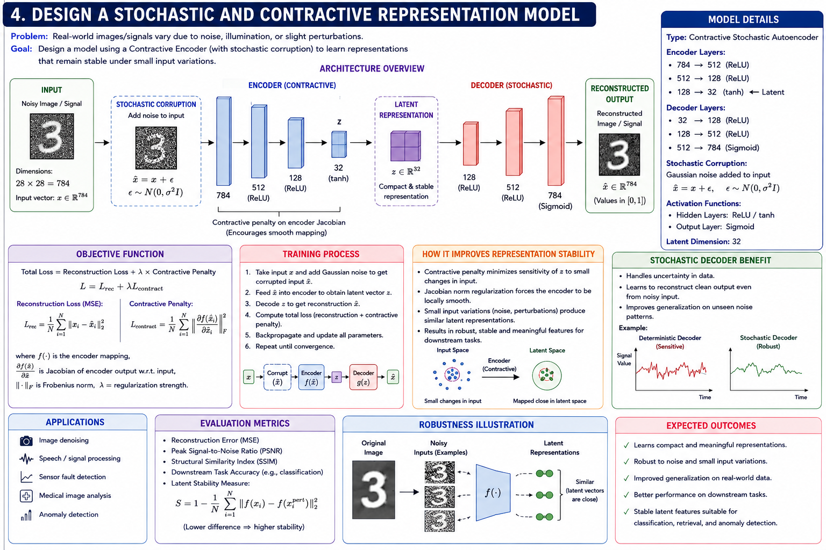

Contractive Mechanism
The key idea is to penalize the sensitivity of the encoder to small changes in the input.
The objective can be written as:
[
L = L_{reconstruction}+\lambda ||J_f(x)||_F^2
]
where (J_f(x)) is the Jacobian matrix of the encoder representation with respect to the input and (||J_f(x)||_F^2) is its squared Frobenius norm.
The first term ensures that the input can be reconstructed, while the second term encourages the latent representation to change slowly when the input changes slightly.

Robustness Mechanism
Suppose two images differ only slightly because of noise or illumination. The contractive penalty encourages their latent representations to remain similar. Therefore, the representation focuses more on important structures such as shapes, edges, and patterns rather than small unwanted variations.

Alternative Stochastic Approach
A stochastic encoder can also introduce controlled randomness into the latent representation:
[
z=\mu+\sigma\epsilon
]
where (\epsilon) is random noise. Training the decoder to reconstruct the input encourages the model to learn a useful distribution rather than a fixed memorized representation.

Evaluation
- Reconstruction error
- Classification accuracy
- Robustness to Gaussian noise
- Robustness to small image transformations
- Latent-space similarity
- Feature stability

Expected Outcome
The proposed contractive model should produce stable features that remain useful under small input variations. This makes it suitable for noisy image and signal-processing applications.

5. Design a GAN-Based Data Generation System

Real-World Problem
An organization has only a small number of training images. Training a deep-learning classifier with such a limited dataset can cause overfitting. A Generative Adversarial Network (GAN) can generate additional synthetic images that resemble the real training samples.

Requirements
- Input to Generator: Random noise vector.
- Generator Output: Synthetic image.
- Discriminator Input: Real or synthetic image.
- Discriminator Output: Probability that the image is real.
- Goal: Generate realistic additional training samples.

GAN Architecture

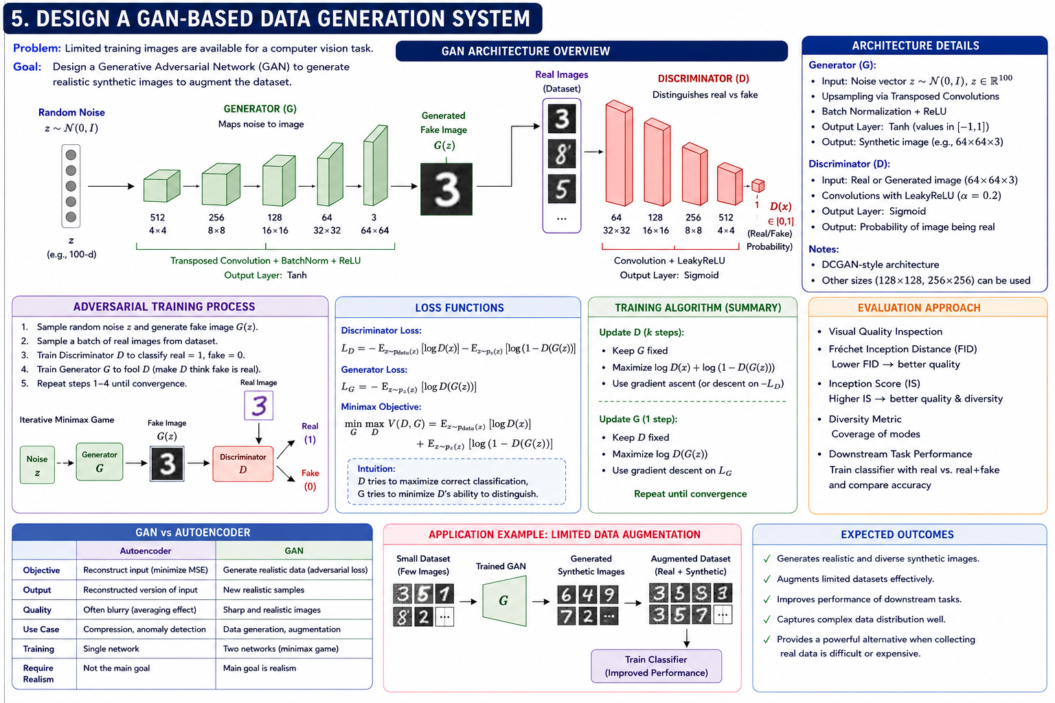

The generator starts with a random noise vector, for example 100 dimensions. Dense and transposed-convolution layers progressively convert this vector into an image.
Example:
Noise: 100
↓
Dense: 4×4×512
↓
ConvTranspose: 8×8×256
↓
ConvTranspose: 16×16×128
↓
ConvTranspose: 32×32×64
↓
ConvTranspose: 64×64×3
↓
Synthetic Image
ReLU can be used in hidden generator layers, while tanh is commonly used at the final layer when images are normalized to ([-1,1]).

Discriminator
The discriminator receives both real images and generated images.
Image 64×64×3
│
▼
Convolution + LeakyReLU
│
▼
Convolution + LeakyReLU
│
▼
Flatten
│
▼
Dense
│
▼
Sigmoid
│
▼
Real / Fake

Adversarial Training
The generator attempts to produce images that fool the discriminator, while the discriminator attempts to distinguish real images from generated ones.
The traditional GAN objective is:

[

\min_G\max_D V(D,G)
E_{x\sim p_{data}}[\log D(x)]
+
E_{z\sim p_z}[\log(1-D(G(z)))]
]
The discriminator learns to classify real and fake images correctly. The generator learns to generate increasingly realistic images.

Training Workflow
- Generate a random noise vector.
- Generator converts noise into a synthetic image.
- Discriminator receives real and generated images.
- Discriminator calculates real/fake predictions.
- Update discriminator weights.
- Generate another batch of fake images.
- Update generator using the discriminator's feedback.
- Repeat until generated images become realistic.

Evaluation
GAN quality can be evaluated using:
- Fréchet Inception Distance (FID)
- Inception Score
- Precision and recall for generated distributions
- Visual inspection
- Diversity of generated images
- Performance improvement of the downstream classifier

GAN vs Autoencoder
Feature | Autoencoder | GAN
Main purpose | Reconstruction and representation learning | Data generation
Training | Encoder + decoder | Generator + discriminator
Output | Reconstruction | New synthetic samples
Main objective | Minimize reconstruction error | Adversarial objective
Image sharpness | Can produce blurry outputs | Usually sharper and more realistic
Feature learning | Strong | Possible but generation-focused
Best use | Compression, denoising, feature extraction | Synthetic data generation

Why GAN Is Suitable
For the given problem, the main requirement is to generate realistic new training images. GANs are specifically designed to learn the distribution of real data and produce new samples from that distribution. Unlike a conventional autoencoder, which primarily learns to reconstruct its input, the GAN's generator learns to create new images that can closely resemble real images.

Expected Outcome
The GAN should generate diverse and realistic synthetic images. These samples can be added to the limited original dataset, increasing the effective training data and potentially improving the performance and generalization of the downstream image-classification model.

